IMAGE AND NARRATIVE IN ROMANESQUE ART
Monday 28th March - Wednesday 30th March 2022

THE BRITISH ARCHAEOLOGICAL ASSOCIATION

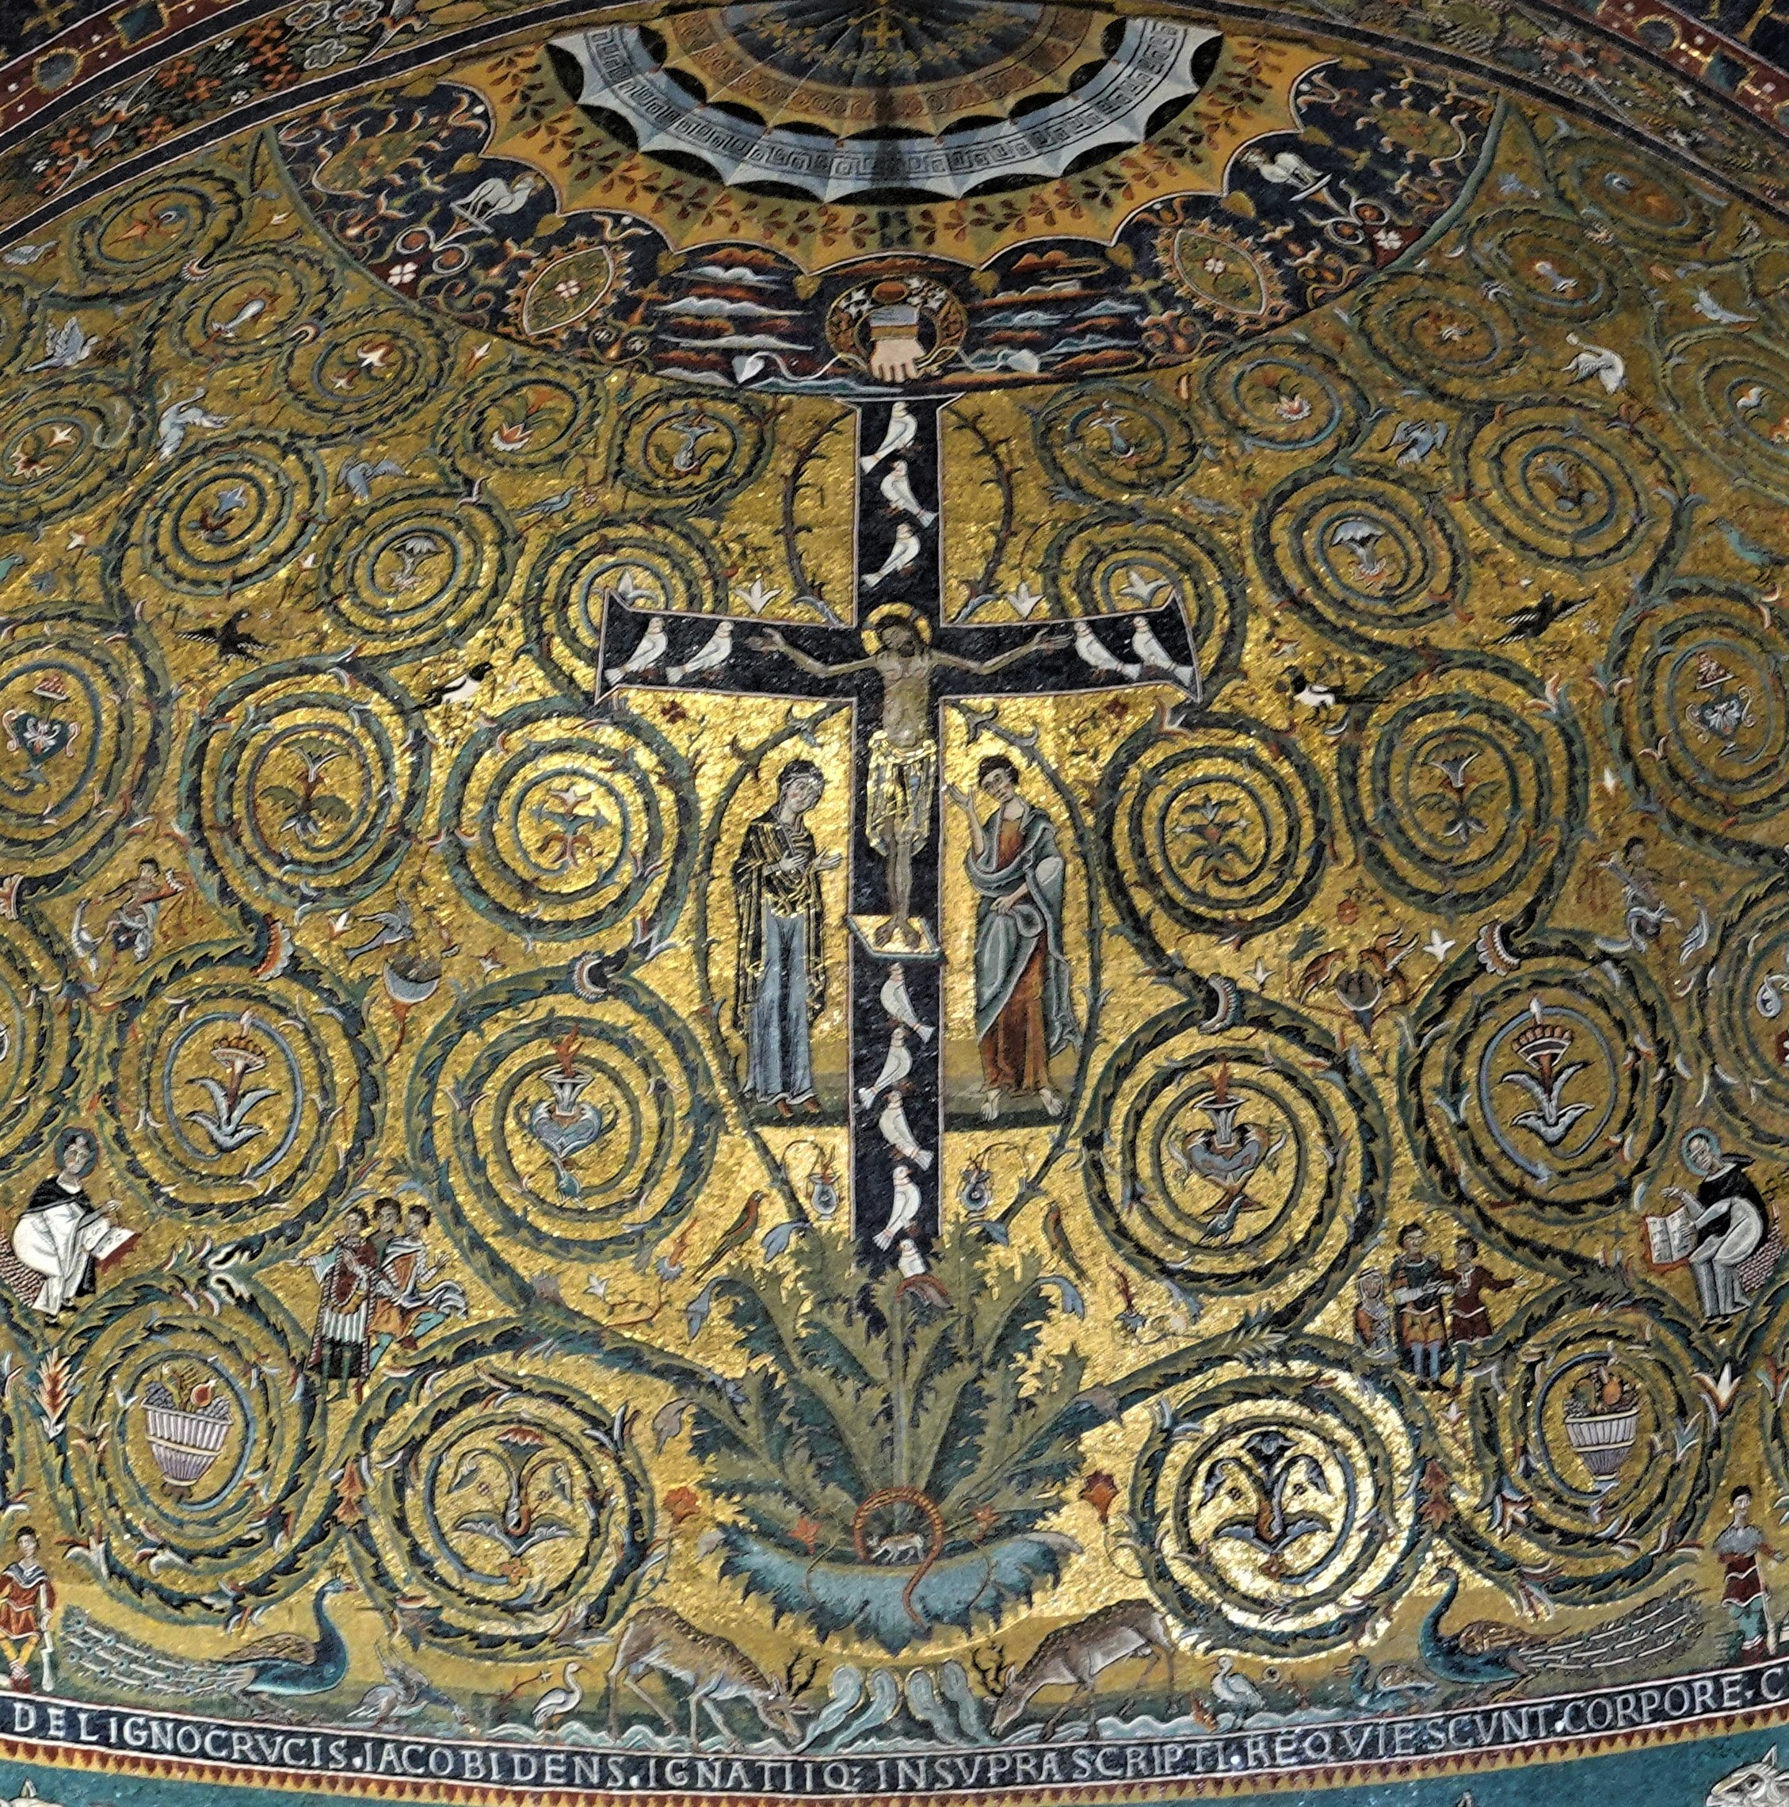

A Three-Day International Conference in the British School at Rome concerned with the conception, production, deployment and reception of imagery in Latin Europe between c.1000 and c.1200. There is an opportunity to stay on for two days of visits to monuments in and around Rome.

BRITISH
ARCHAEOLOGICAL ASSOCIATION

The British Archaeological Association will hold the seventh in its biennial International Romanesque conference series in conjunction with the British School at Rome on 28-30 March, 2022. The theme is Image and Narrative in Romanesque Art, and the aim is to examine the use of imagery in the Latin Church between c.1000 and c.1200. The Conference will take place at the British School, with the opportunity to stay on for two days of visits to Romanesque monuments on 31 March and 1 April.

While illustrated codices, sequential pictorial narratives, apse mosaics, and devotional statues were well established before c.1000, several important new image types and settings came into being over the Romanesque period – figuratively enriched portals, historiated cloisters, moralizing programmes, imagery in glass. The conference will consider imagery in its various manifestations, exploring narrative modes, the significance of spatial positioning and visibility, the uses and physical trappings of devotional images, the relationship between political or reformist agendas and the rhetorical power of imagery, and the extent to which media play a role in the development or importation of new iconographical formulae. Are images invested with singular meanings, or are they intentionally polysemous? Does the interest in architectural ‘articulation’ initiate a new understanding of the expressive and aesthetic potential of imagery, and/or emphasise its didactic purpose? Are viewers provided with guidance as to interpretation – through inscriptions, or compositional and visual triggers? How does material and setting affect imagery? How might we understand image and narrative in the Latin West between c.1000 and c.1200?

Speakers include Kristen Aavitsland, Marcello Angheben, Claude Andrault-Schmitt, Giulia Arcidiacono, Yael Barash, Tancredi Bella, Jessica Berenbeim, Armin Bergmeier, Irene Caracciolo, Manuel Castiñeiras, Gaetano Curzi, Barbara Franzé, Deborah Kahn, Wilfried Keil, Robert Maxwell, John McNeill, Mina Miyamoto, Alison Perchuk, Claudia Quattrocchi, Arturo Carlo Quintavalle, Serena Romano, Carles Sanchez, Béla Zsolt Szakács, Rose Walker, and Andrea Worm.

CONFERENCE
The conference will open at 09.00 on Monday, 28 March with lectures in the main auditorium of the British School at Rome. Teas, coffees and lunch will be provided on all three days, in addition to dinner on two evenings and a reception. More information will be provided in the joining instructions. Participants will need to arrange their own travel and accommodation.

HOWEVER, as a result of Covid rules on social distancing the auditorium of the British School is currently allowed to operate at 50% capacity. We hope this will change, but if it does not conference places will be limited. We therefore invite those who wish to attend the conference to fill in the booking form. Acceptance will proceed in two stages. If your booking can be accepted while restrictions on numbers remain at 50%, you will be contacted and asked for your conference fee. If not, you will be placed on a waiting list and in the event that restrictions are lifted we will contact you immediately. If you are still interested, we will then ask for the conference fee.

VISITS
We will also organise two days of visits to Romanesque sites for those who wish to stay on. These will include a number of churches in Rome itself, along with selected monuments in northern Lazio at Ceri, Tarquinia, Tuscania and Castel Sant’Elia.

SCHOLARSHIPS
A limited number of scholarships to help cover the cost of the conference for students are available. Please apply by 5 January 2022, attaching a short CV along with the name and contact details of one referee. Applications should be sent to: jsmcneill@btinternet.com and rplant62@hotmail.com

It would not be possible to mount this conference without John Osborn, and the British Archaeological Association wishes to take this opportunity to thank him for the boost to Romanesque scholarship afforded by his great generosity.

Conference Convenors: Grazia Fachechi and John McNeill
Conference Secretary: Ann Hignell

Image and Narrative in Romanesque Art
Conference Booking Form

As a result of Covid rules on social distancing the auditorium of the British School is currently allowed to operate at 50% capacity. We hope this will change, but if it does not conference places will be limited. We therefore invite those who wish to attend the conference to fill in the booking form. Acceptance will proceed in two stages. If your booking can be accepted while restrictions on numbers remain at 50%, you will be contacted and asked for your conference fee. If not, you will be placed on a waiting list and in the event that restrictions are lifted we will contact you immediately. If you are still interested, we will then ask for the conference fee.

Name:……………………………………………………………………………………..

Title (Mr Mrs Ms Miss Dr Professor)

Contact address:

e-mail address:……………………………………………………………………………..

Mobile tel.…………………………………………………………………………

Professional affiliation for conference register………………………………………………

Conference fee (28-30 March): £265
Includes all lectures, teas/coffees, lunches, two dinners and one reception.

Visits fee (31 March-1 April): £80
Includes admission charges, donations and coach travel in northern Lazio on 1 April.

Please do not send any money for the moment. If your booking is accepted you will be sent a request for payment.

Please USE BLOCK CAPITALS and send the booking form by post, or as an email attachment, to
Ann Hignell, 24 Orchard Close, Ruislip, Middlesex HA4 7LS - aehignell@yahoo.com

The initial deadline is 21 December 2021

