British Archaeological Association
The Courtauld Gallery Reopening Study Day
Friday 10 December, 2021
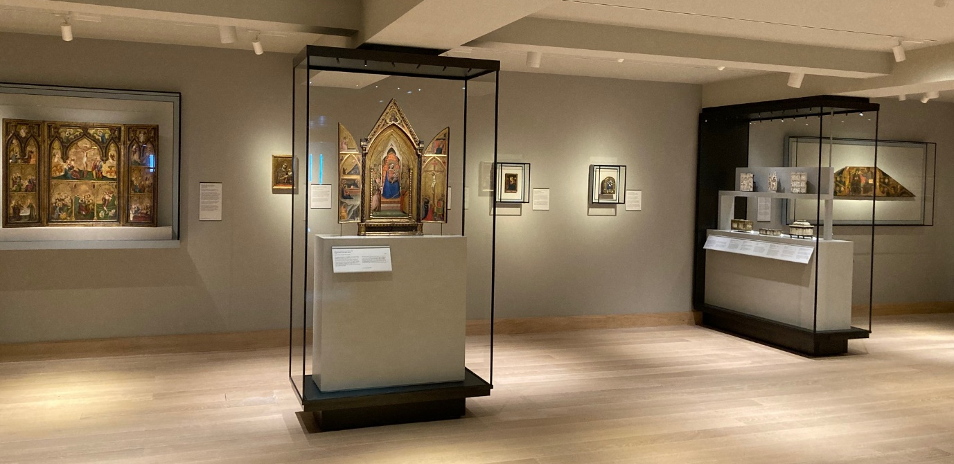
The Courtauld Gallery, Somerset House
This study day offers a chance to see the Courtauld’s beautiful new medieval gallery, which re-opens on 19 November following the most significant modernisation project in the gallery’s history. The visit includes an introduction to the new displays by Dr Emma Rogers, and a handling session in the gallery’s new object handling room, including a number of medieval enamels and ivories.
Programme:
11.30 Meet in the reception area of the Courtauld Gallery.
11:30 – 13:00 Handling session and visit to the new galleries (the group will be divided in two).
13:00 – 14:30 Break for Lunch
14:30- 15:15 Visit to the exhibition of Tony Kersting photos of Kurdistan, from the Courtauld’s Conway library, with curator Tom Bilson
The study day fee is £20 for members (please bring this with you; cheque or cash) and free for students. The students do not have to pay the fee and they will be reimbursed their travel expenses (up to £50). The Study Day is limited to a maximum of 14 people – 7 students and 7 members. Email studydays@thebaa.org by November 26th to register. We will notify you of the outcome by November 27th.

