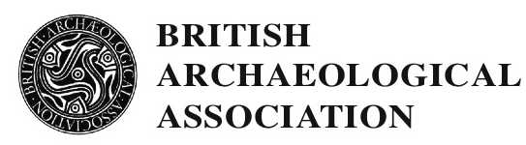

KOŠICE: MEDIEVAL ART AND ARCHITECTURE IN EASTERN SLOVAKIA
20TH - 24TH JULY 2022

STUDENT SCHOLARSHIPS
The 2022 BAA Conference will explore the art, architecture and archaeology of the medieval town of Kosice and the surrounding area in Eastern Slovakia.
A full programme of lectures and visits has been arranged.
Lectures will explore the medieval history of Slovakia and Košice, including Gothic and Romanesque architecture, manuscripts, wall paintings and altar pieces from the 15th & 16th centuries. Speakers include: Dušan Buran, Gabor Endrodi, Eric Fernie, Jana Gajdošová, Alexandra Gajewski, Zoltan Gyalokay, Krisztina Ilko, Zsombor Jékely, Tim Juckes, Zoë Opačić, Robert Maniura, Peter Megyesi, Maria Theissen, Béla Zsolt Szakacz, Peter Tajkov, Tomasz Weclawowicz.
Site visits in Košice will include St Elizabeth’s Cathedral and the chapel of St Michael, as well as a walking tour around the old town. There will be three coach excursions outside Košice - two half days and one full one. These will encompass Bardejov, a UNESCO world heritage site famous for the church of St Giles which has 12 intact medieval altarpieces, the medieval town hall (with a high quality collection of medieval sculptures) and its large medieval square; the Gemer region, celebrated for its 13th and 14th century wall paintings and its late Romanesque rotunda in Šivetice; the Spiš Region, including Levoča, also a UNESCO world heritage site with the church of Saint James displaying the famous 18 metre altar by Master Paul of Levoča, Spišsky Stvrtok, Spišska Kapitula, Kežmarok, and Strážky.
Applications are invited for student scholarships. The conference will run from 9.00am on Wednesday 20th July to lunchtime on Sunday 24th July, 2022. Scholarships will only be awarded to those who can attend the conference in its entirety. The scholarship covers lectures and site visits, accommodation for five nights, and all included meals, refreshments and receptions.
Applicants should email catherinemilburn@madasafish.com enclosing a brief CV, at least one academic reference and a brief statement on the reasons for wanting to attend the Conference and how it might relate to your own research. The deadline for applications is 31st May 2022. Applicants will be notified by 7th June 2022. Please note that it is the responsibility of the applicant to either send the academic reference with the application or to make sure their nominated referee sends it in. BAA will not chase for references.
Scholarships are given to those studying at postgraduate level and those who have been awarded research degrees in these areas within the last two years. The scholarships are funded by the generosity of BAA members and the number awarded varies according to the funds available. Successful applicants are expected to join the BAA if not already members. The maximum number of scholarships to attend a BAA summer conference to any one individual is two.

