David McLees (1945-2020)
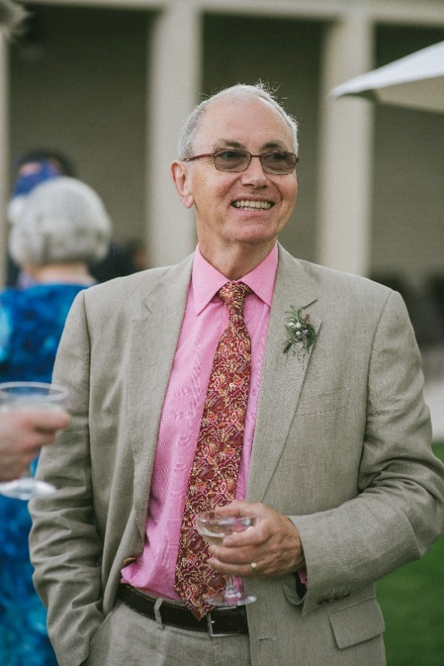
David studied at the Courtauld Institute, an academic background which underpinned his subsequent work as an Inspector of Historic Buildings, first for the Department of the Environment, then the Scottish Office and subsequently the Welsh Office and its successor the Welsh Assembly Government. In the 1970s and 80s he was an active member of the British Archaeological Association, serving on its council for many years and leading tours at annual conferences. In 1972 he won the Reginald Taylor Essay Prize for his work on Henry Yevele, which was published in the BAA Journal the following year (Henry Yevele: Disposer of the King’s Works of Masonry, JBAA 3rd series: vol: 36, 1973), and served as Reviews Editor of the JBAA from 1975-84.
When responsibility for listing in Wales was transferred from London to Cardiff in 1984, David was appointed as the listing Inspector to take charge of this. It was an important step towards securing statutory protection for a more diverse and representative range of Wales’s heritage than had previously been the case. His work gave due attention to the significance of vernacular buildings, non-conformist chapels and industrial buildings. Indeed, it was striking in those early years just how many important buildings he discovered and ensured were protected through listing. He built up a small team who were then further augmented by freelance consultants carrying out specific surveys under contract. He led the listing programme until 2006 when he retired and, over the years, he contributed widely to Cadw’s knowledge of architectural history and the heritage of Wales. For example, he wrote the highly regarded guidebook to Castell Coch.
David’s sensitivity meant that he felt deeply the very real challenges of the job. His uncompromising insistence on high academic standards and sound research created lists for Wales that were robust and of a quality that were able to withstand the frequent challenges from the ever-changing political leadership. He also led the way in the UK in producing statutory lists that clearly explained what was significant about each building and why they were judged to merit listing. He had an amazing breadth of knowledge, worn modestly and combined with a wonderful sense of humour. He passed away in June 2020 after a short illness but is very warmly remembered and respected by many throughout the heritage sector in Wales, to which he made such a key contribution.
Edward Holland (friend and former colleague at Cadw)
David’s daughter, Fiona McClees adds……..My father's deep care and love for architectural history and ancient monuments extended far beyond his professional life and coloured many of the childhood memories of my two sisters and myself. Days out with him could often include "phonebox hunting" around South Wales in his quest to identify and list the classic red Gilbert Scott telephone boxes, and as occasional assistants we became familiar with the names of Carron Company and the crests of different royalty which appear on these and on the red letterboxes which might also be part of the hunt. During family holidays in Cornwall and Ireland we would tramp across fields to explore fogous or look at ancient Celtic crosses, or run about in ruined castles and sit sketching dolmens. His unbelievably capacious memory would mean that he was always the best-informed guide that one could have to a historic site, something which we are already greatly missing. His interest in heritage was perhaps only matched by an unerring ability to unite a day out to a building or monument with a fine pub, farm shop, or other local eatery. I know this is something that was deeply appreciated by his friends too, especially following his retirement when he had more time for leisurely trips and could easily be persuaded to spend a day pottering between churches with a pub lunch in between. He instilled in the whole family a lasting interest in heritage, art, and fine food, which I think has enriched all our lives greatly. We miss him deeply and hope that when circumstances allow we will be able to meet with his friends and colleagues to celebrate him in a suitable fashion, with delicious foods and happy memories.

