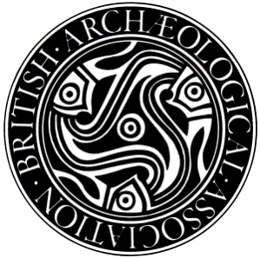 British Archaeological Association
Old Sarum Study Day
Saturday 10 October 2020
Programme:
Meet in front of Salisbury Cathedral at 11.00 (in west walk of cloister if raining). There is a train from Waterloo at 9.20 which arrives at Salisbury station at 10.50 for anyone travelling from London.
11:00 – 13:00 Salisbury cathedral and Museum with Tim Tatton-Brown and John McNeill
We will look at the material from Old Sarum which survives in the precinct and divide into groups. Tim Tatton-Brown will take participants to look at the reused material from Old Sarum on the Close Wall; John McNeill will concentrate on the Old Sarum material in the museum.
13:00 – 14:15 Lunch break
14:30 – 16:30 Old Sarum with Tim Tatton-Brown and John McNeill
The study day fee is £20 for members (please bring this with you; cheque or cash) and free for students. All participants will have to book into Old Sarum, for which there is a fee of £5.90 (free for English Heritage Members). Students will be reimbursed their travel expenses. The Study Day is limited to a maximum of 20 people – 10 students and 10 members. Email studydays@thebaa.org to register.
IMPORTANT: Current regulations for visits to the Cathedral, Museum and Old Sarum require all visitors to wear face masks

