ANNUAL CONFERENCE 2023

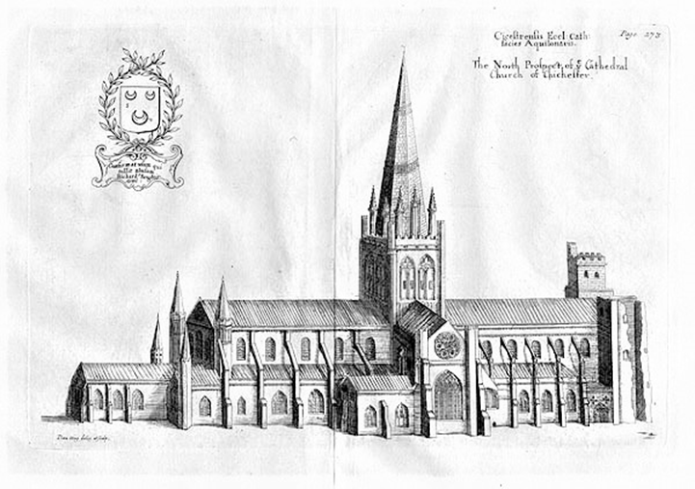
MEDIEVAL CHICHESTER: CATHEDRAL, CITY AND SURROUNDINGS
4TH - 8TH SEPTEMBER 2023

The postponed Chichester Conference will now take place from 4th September to 8th September (Monday to Friday) 2023. When the British Archaeological Association gathers in Chichester, it will be the last of the English cathedral cities to be visited since the resumption of conference transactions in 1975. Thus, in addition to the Cathedral itself, the conference will consider the many buildings associated with the cathedral, the vicars’ close and the bishop’s palace, and the wider architectural landscape of West Sussex.
Lectures will include papers on subjects covering many aspects of the architecture of the Cathedral, Romanesque and Gothic, wall paintings, the architecture of Medieval West Sussex and its Roman past. Speakers include Jessica Barker, David Bone, John Crook, Kate Davey, Ute Engel, Agata Gomolka, Martin Henig, Christine Kimbriel, Claudia Marx, Michael Michael, Julian Munby, Tom Nickson, David Parsons, Richard Plant, Tim Tatton-Brown, Malcolm Thurlby, Frank Woodman and Andrea Worm.
The conference will be based at Chichester University, within walking distance of the Cathedral and city centre. Proposed site visits outside the city will include Boxgrove Priory, Old and New Shoreham, Arundel, and Coombes.
Booking forms will be available in 2023. All enquiries about the conference should be sent to the Hon. Conference Secretary, conferences@thebaa.org

