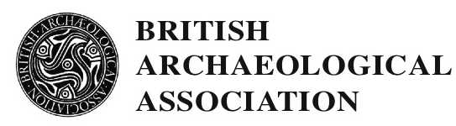

SHREWSBURY CONFERENCE 2019

Monday 15th July to Friday 19th July

STUDENT SCHOLARSHIPS

The 2019 BAA Conference will explore the art, architecture and archaeology of medieval Shrewsbury and north Shropshire. Lectures will include papers on subjects as varied as late Roman Shropshire, Shrewsbury’s medieval topography, the patronage, art, architecture and archaeology of medieval churches in and around Shrewsbury, stone sculpture, alabasters, roof bosses, seals, and nineteenth-century antiquarianism.

Site visits will include St Mary’s, St Alkmund, Bear Steps, the Town Walls and Shrewsbury Abbey, while there will be two coach excursions (one full & one half-day) outside Shrewsbury. These will encompass Acton Burnell (church and castle), Wenlock Priory, Buildwas Abbey, Haughmond Abbey, Atcham, Shifnal, and Tong.

Applications are invited for student scholarships. The conference will run from lunchtime on Monday 15th July to lunchtime on Friday 19th July, 2019. Scholarships will only be awarded to those who can attend the conference in its entirety. The scholarship covers lectures and site visits, accommodation for four nights, and all included meals, refreshments and receptions.
Applicants should email catherinemilburn@madasafish.com enclosing a brief CV, at least one academic reference and a brief statement on the reasons for wanting to attend the conference and how it might relate to your own research. The deadline for applications is 15th April 2019. Applicants will be notified by 3rd May 2019. Please note that it is the responsibility of the applicant to either send the academic reference with the application or to make sure their nominated referee sends it in BAA will not chase for references.
Scholarships are given to those studying at postgraduate level and those who have been awarded research degrees in these areas within the last two years. The scholarships are funded by the generosity of BAA members and the number awarded varies according to the funds available. Successful applicants are expected to join the BAA if not already members. The maximum number of scholarships to attend a BAA summer conference to any one individual is two.

