ANNUAL CONFERENCE 2019
‘ART, ARCHITECTURE AND ARCHAEOLOGY IN SHREWSBURY AND NORTH SHROPSHIRE FROM THE ROMAN PERIOD TO THE LATE MIDDLE AGES’

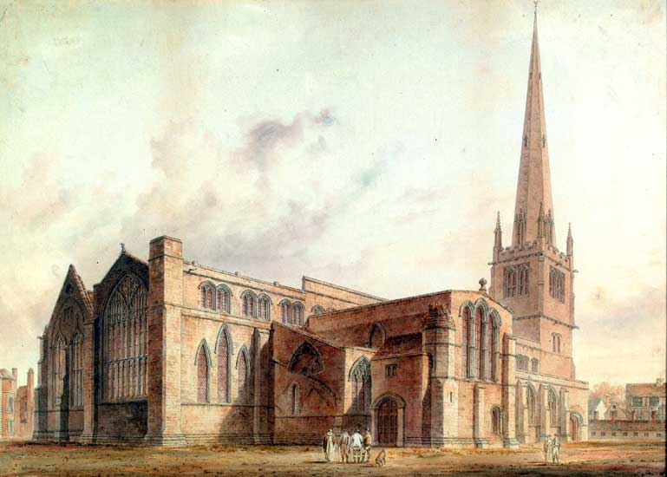

12.30 pm Monday 15th July to 1.00 pm Friday 19th July

TIMING
Please note that this year, unusually, the conference will start on a Monday and end on a Friday. The conference opens for registration on the 15th July at 12.30pm in the Walker Theatre Shrewsbury. The President’s Welcome and Introduction will be at 2.00pm followed by the first lecture at 2.15pm. The conference will conclude at l.00pm on Friday 19th July. The conference convenors are John McNeill (BAA Honorary Secretary) and Dr. Elizabeth New (Aberystwyth University).

Location
The conference is based at Walker Theatre, part of the Theatre Severn complex, Frankwell Quay, Shrewsbury SY3 8FT. To walk from the station takes around 10 minutes. Lectures will take place in the Walker auditorium. Meals and receptions will take place in and around Shrewsbury. There will be site visits exploring the important buildings in Shrewsbury, and two coach excursions which will include Acton Burnell, elock Priory, Buildwas, Haughmond, Atcham, Shifnal and Tong.

LECTURES
Lectures will include papers on subjects as varied as late Roman Shropshire, Shrewsbury’s medieval topography, the patronage, art, architecture and archaeology of medieval churches in and around Shrewsbury, stone sculpture, alabasters, roof bosses, seals, and nineteenth-century antiquarianism. Speakers include Ron Baxter, Meg Bernstein, James Cameron, Gillian Crumpton, John Cherry, Richard Gem, Heather Gilderdale-Scott, Richard Halsey, Martin Henig, Julian Luxford, John McNeill, Elizabeth New, Caroline Novak, Cathy Oakes, David Robinson, Trevor Rowley, Spencer Smith, Alan Thacker, Jeff West, Roger White, Will Wyeth, and Victoria Yuskaitis

SITE VISITS
Site visits will include St Mary’s, St Alkmund, Bear Steps, the Town Walls and Shrewsbury Abbey, whole there will be two coach excursions (one full & one half-day) outside Shrewsbury. These will encompass Acton Burnell (church and castle), Wenlock Priory, Buildwas Abbey, Haughmond Abbey, Atcham, Shifnal, and Tong.

Travel
There are reasonably frequent trains to Shrewsbury (the gateway to Wales!) from London Euston, changing at either Birmingham International, Birmingham New Street or Crewe, taking approx. 2½ hours. From Glasgow & Edinburgh the journey takes approx. 3½ hours changing at Crewe and from York/Leeds approx. 2 ½ hours changing at Manchester Piccadilly. There is one coach a day from Victoria Coach Station which takes 5 hours. The nearest airports to Shrewsbury are Birmingham, Liverpool and Manchester. If you come by car you will need to use the M54 / M6 network or the A49, A5, A53, A458 if approaching by A roads.

ACCOMODATION
Delegates will need to arrange their own accommodation. A small selection of some hotels and B/Bs in Shrewsbury are given below.

Premier Inn (very near the Walker Theatre) Single rooms currently £55.00 per night but this doesn’t include breakfast. Parking £8 for 24hrs. Smithfield Rd, Shrewsbury SY1. Tel: 0871 527 9402 https://www.premierinn.com/Shropshire/Shrewsbury

The Lion Hotel (which is hosting the two of the dinners and a reception) is offering B&B at £65.00 per night for a single room or £85.00 per night for a double/twin room (simply state you are attending the BAA conference). The décor and rooms are quirky but comfortable and there is lift access. It is approximately 12 minutes walk to the Walker Theatre. It is also from here Charles Darwin set out to join T with he Beagle so rub shoulders with history by staying in the Darwin Suite.
Wyle Cop, Shrewsbury, SY1 1UY: Tel: 01743 353107: Email: info@thelionhotelshrewsbury.com

Prince Rupert Hotel – has single rooms at £95.00 per night and £145.00 per night for double/twin room. Not cheap it is however very central and gets excellent reviews on Trip Advisor. Includes breakfast and parking.
Butcher Row, Shrewsbury SY1 1UQ Tel: 01743 499955 www.princeruperthotel.co.uk

The Shrewsbury Hotel - has rooms overlooking the river and is near the Walker Theatre. Single and double rooms are £79.00 per night. Breakfast is not included but there is a restaurant and limited free parking.
Bridge Place, Shrewsbury SY1 1PU Tel: 01743 236203 www.jdwetherspoon.co.uk

Castlecote Guest House. Single en suite from £35.00 per night and double en-suite £60.00 per night. Has off street parking.
77 Monkmoor Road, Shrewsbury SY2 5AT Tel: 01743 245473 email: info@castlecote.co.uk

Anton Guest House - has single rooms at £60.00 per night and £67.50 per night for double rooms. Breakfast included. 1 Canon Street, Shrewsbury, Shropshire SY2 5HG Tel: 01743 359275 email: antonguesthouse@btconnect.com
The Vaults – has a number of rooms both single & double rooms ranging from £40.00-£50.00 per night. Breakfast not included and no parking. Very near the station.
16 Castle Gates, Shrewsbury SY1 2AB Tel: 01743 358807 www.the-vaults.co.uk
More hotels and guest house can be found on Booking.com, Air B & B Shrewsbury, and the Tourist information office https://originalshrewsbury.co.uk/

PARKING
Council car parks in Shrewsbury are priced in bands; the further from the centre of the town, the cheaper the car park. You can stay for as long as you want in the car parks or on-street and they are priced per hour (there is a time limit for stays in Frankwell Riverside, due to flooding risk). For more information on parking click on the link below.
https://originalshrewsbury.co.uk/see-do/travel-informatio
FOOD
Sandwich lunches will be provided on Tuesday and Thursday. On Monday evening there is a sit down dinner at the Morris Hall. On Tuesday evening there will be drinks followed by a 3-course dinner at the Lion Hotel. On Wednesday afternoon there will be a reception with canapes at Haughmund Abbey, followed by a free evening - a list of local restaurants will provided in the conference pack. The conference dinner with a reception beforehand will be held on Thursday at the Lion Hotel.
DIETARY REQUESTS
Please let us know any dietary requests you might have on the booking form.
ACCESS
The Walker lecture theatre situated on the third floor, has raked seating and excellent acoustics. There is lift access. The sandwich lunches, teas and coffees on Tuesday and Thursday will be served just outside the theatre. Copies of the BAA Transactions will also be on sale here. Shrewsbury is a hilly town with narrow streets so the site visits will not all be on the flat. Some of the excursions outside Shrewsbury will also be on uneven ground. Good walking shoes are advised. Please let the conference organisers know if you have mobility problems.

Student scholarships
A limited number of scholarships will be available for students, covering the conference fee and accommodation. Please email catherinemilburn@madasafish.com for further details if you wish to apply. The deadline for student scholarship applications is 15th April, 2019.
We continue to be very grateful indeed to delegates who add donations for the student scholarships. The booking form shows you how this can be done.

Cost
The conference fee is £295.00, which includes 3 dinners, 2 lunches, 2 receptions and tea/coffee refreshments during the conference lectures in the Walker Theatre and on Tuesday afternoon.

Booking and next steps
Booking forms and cheques (payable to the British Archaeological Association) should be sent to Kate Milburn at 34 Latimer Road, London, SW19 1EP by 15th April, 2019. Attendees from outside the UK may pay via PayPal or Bank Transfer (see booking form). We will use email for further contact. If you do not have email, please send two SAEs with your Booking Form.
Booking for the Conference is on a first come, first served basis.
We will email or post confirmation of your booking. Joining instructions, with a provisional programme, will be sent out in the middle of June. If you have any questions regarding the conference please email Kate Milburn - catherinemilburn@madasafish.com

