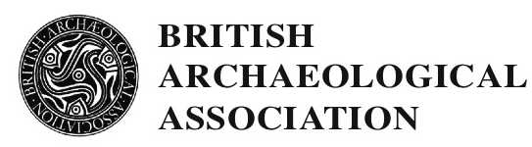

YORK CONFERENCE 2017

Friday 21st July to Tuesday 25th July

STUDENT SCHOLARSHIPS

A full programme of lectures and visits has been arranged. The 2017 Conference will explore Art, Architecture and Archaeology in Late Medieval York including introductory surveys of Roman York, and Early Medieval and Anglo-Scandinavian York; and papers covering York Castle, York Minster, including the Chapter House; and other late medieval ecclesiastical and secular buildings in York, including St Michael-le-Belfrey.
Speakers include Peter Addyman, Jeremy Ashbee, Richard Beadle, Sarah Brown, Alex Buchanan, Kate Giles, Jeremy Goldberg, David Harrison, Stuart Harrison, Alex Holton, Ailsa Mainman, Hilary Moxon, Julian Munby, Christopher Norton, Patrick Ottaway, John Oxley, Christopher Paterson, Philippa Turner, Lisa Reilly, Sarah Rees Jones, Jayne Rimmer, and Mary Shepard.
There will be site visits to various parts of York Minster, walking tours south and north of the river which we hope will include St Mary’s Abbey, The Yorkshire Museum, All Saints North Street, Holy Trinity Micklegate, Baile Hill, Clifford’s Tower, St Anthony’s and the Merchant Adventurers’ Halls, Goodramgate, King’s Square, Stonegate and St Helen’s Square. All site visits will be on foot.
For those who wish to stay on there is the possibility of additional site visits on the Tuesday afternoon, details of these will be included in the joining instructions. In addition the Yorkshire Archaeological Trust has very generously offered to admit delegates to their attractions, including Jorvik, free of charge for the rest of the week after the conference finishes on Tuesday.
Applications are invited for student scholarships. The conference will run from 12.30pm on Friday 21st July to lunchtime on Tuesday 25th July, 2017. Scholarships will only be awarded to those who can attend the conference in its entirety. The scholarship will cover the lectures and site visits, accommodation for four nights, four dinners and refreshments throughout.
Applicants should email baa-2017@york.ac.uk enclosing a brief CV, at least one academic reference and a brief statement on the reasons for wanting to attend the conference. The deadline for applications is 21st April 2017. Applicants will be notified by 5th May 2017. Please note that it is the responsibility of the applicant to send the academic reference with the application; the BAA will not chase references.
Scholarships will be allocated by the members of the BAA council and are usually given to those studying medieval art, architecture or archaeology at postgraduate level. The scholarships are funded by the generosity of BAA members and the number awarded varies according to the funds available. Successful applicants are expected to join the BAA if not already members.

